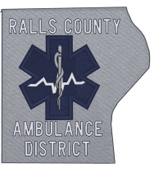

Ralls County Ambulance District

142 Jaycee Drive

Hannibal, Missouri 63401

Phone (573)221-5510 Fax (573)221-5004

July 23, 2024, 1:43p.m.

Notice is hereby given that the Ralls County Ambulance District will conduct a board meeting at 6:00 p.m. on Wednesday, July 24, 2024, at Ralls County Courthouse, New London, Missouri.

The tentative agenda of this meeting includes:

1. Call to order.
2. Reading and approval of minutes of the meeting held on June 18, 2024.
3. Review reports for June 2024.
4. Old Business
5. ARPA Grant
6. New Ambulance
7. Perry Generator
8. Adjourn

Representatives of the news media may obtain copies of this notice by contacting:

John Nemes

142 Jaycee Drive

Hannibal, MO 63401

573-221-5510